River of Deceit
Mad Season

[Intro]

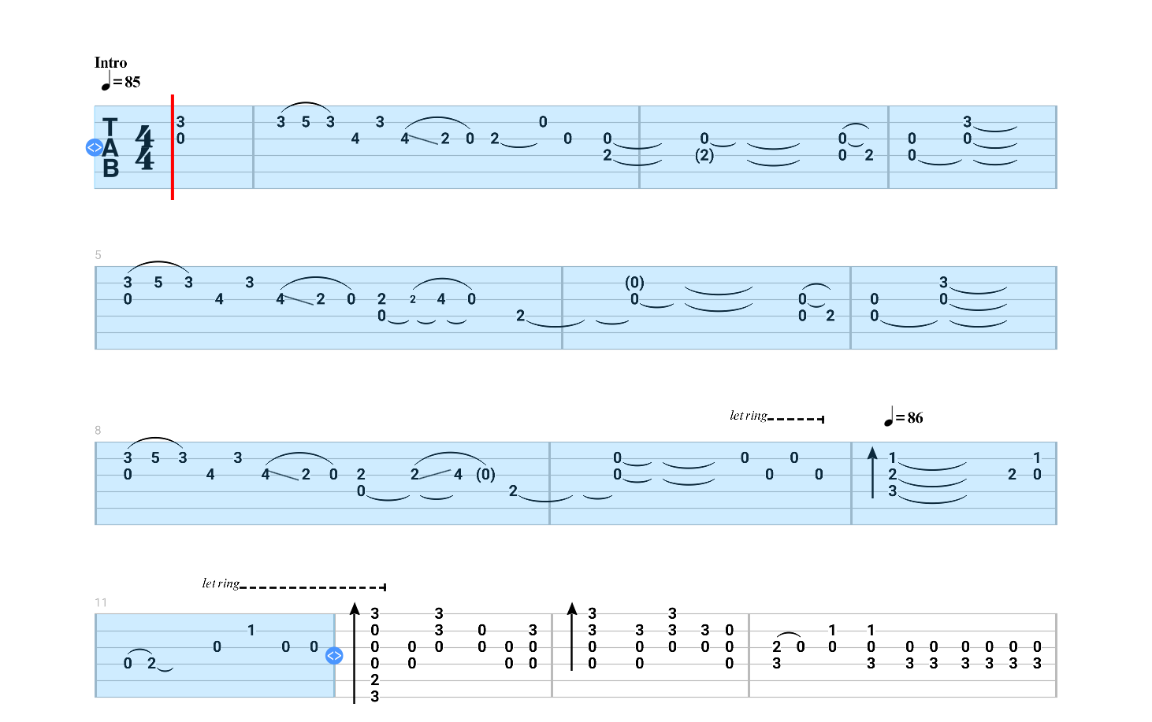

G Em
G Em
G Em

F C/E

G(Gsus4)G (F)Fsus2 G(Gsus4)G (F)Fsus2
G(Gsus4)G (F)Fsus2 G(Gsus4)G (F)Fsus2

[Verse 1]
G Fsus2 G Fsus2
My pain is selfchosen
G Fsus2 G Fsus2
At least, so the prophet says
G Fsus2 G
I could either burn
Fsus2 G Fsus2
Or cut off my pride and buy some time
G Fsus2 G
A head full of lies is the weight, tied to my waist

[Chorus]
G/C G/D G/C G/D G/C
The river of deceit pulls down, oh oh
G/D G/C G/D
The only direction we flow is down
Fsus2 G
Down, oh down
Fsus2 G
Down, oh down
Fsus2 G
Down, oh down
Fsus2 G
Down, oh down

[Sax Solo]
Fsus2 G Fsus2 G
Fsus2 G Fsus2

[Verse 2]
G Fsus2 G Fsus2 G
My pain is selfchosen
Fsus2 G Fsus2
At least I believe it to be
G Fsus2 G
I could either drown
Fsus2 G Fsus2
Or pull off my skin and swim to shore
G Fsus2 G
Now I can grow a beautiful shell for all to see

[Chorus]
G/C G/D G/C G/D G/C
The river of deceit pulls down, yeah
G/D G/C G/D
The only direction we flow is down
Fsus2 G
Down, oh down
Fsus2 G
Down, oh down
Fsus2 G
Down, oh down
Fsus2 G
Down, oh down

[Outro]
Fsus2 G Fsus2 G Fsus2
The pain is selfchosen, yeah
G Fsus2 G
Our pain is selfchosen
Fsus2 G
Down, oh down
Fsus2 G
Down, oh down
Fsus2 G
Down, oh down
Fsus2 G Em
Down, oh down

